29.68: 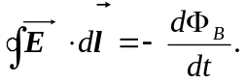
If 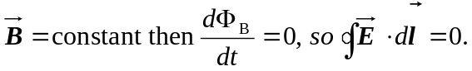
But since we assumed 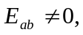 this contradicts Faraday’s law. Thus, we can’t have a uniform electric field abruptly drop to zero in a region in which the magnetic field is constant.

